
To: WV STARS Professional Development (PD) Providers
From: WV STARS
Date: March 3, 2022
Re: New Feature for Scheduled Events

WV STARS PD Providers,

There is a new feature for Scheduled Events that allows those using Scheduled Events to copy an existing Scheduled Event for the creation of an additional instance. Rather than having to schedule the event from scratch each time, all the information from the previous event is copied over to this new instance. To use this feature, simply look for the Scheduled Event you want to use, and you will see the “Action” drop down menu on the far right:

After clicking the drop-down menu, you will see the option “Copy Event” at the top of the action choices:
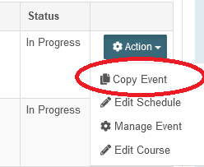

This will take you to a page that is titled “Scheduled Event Copy”. This page will look just like the page you would normally see when creating a brand-new scheduled event:

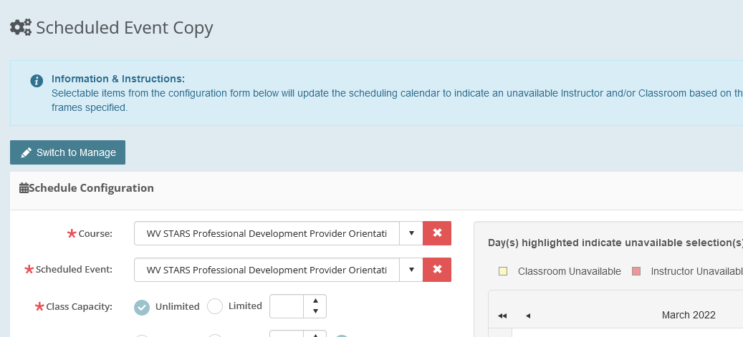

Simply review the new instance and make any changes/updates as necessary.

Click  to complete the process. You will see the Event was created and saved successfully by the notification below. You can now see this new event under your normal list of scheduled events.

If you have any questions about this feature, please contact me. There are additional Scheduled Event features currently in progress, and I will keep you updated as they are released.
Thank you!
Stacy Price, MS  WV STARS Training Specialist  WV State Training and Registry System (WV STARS)  www.wvstars.org  www.facebook.com/wvstars | 611 Seventh Avenue, Suite 322  Huntington, WV 25701  T: 304-522-7827 x3471  F: 304-529-2535  sprice@rvcds.org

Administered by WV Early Childhood Training Connections and Resources, a program of River Valley Child Development Services “Serving Children and Families since 1971”.

